Project Design Phase
Solution Architecture
Date | 30 September 2026
Team ID | SWTID-2026-8157
Project Name | BlogNest – AI-Powered Blog Content Generation & Management Platform
Maximum Marks | 4 Marks

Solution Architecture:
Solution architecture bridges the gap between business problems and technology solutions. For BlogNest its goals are to:
- Find the best tech solution to the content-management and AI-drafting problems described in the problem statements.
- Describe the structure, characteristics and behavior of the BlogNest API to project stakeholders.
- Define features, development phases and solution requirements (authentication, blogs, categories, comments, AI).
- Provide specifications according to which the solution is defined, managed and delivered.
Solution Architecture Diagram:
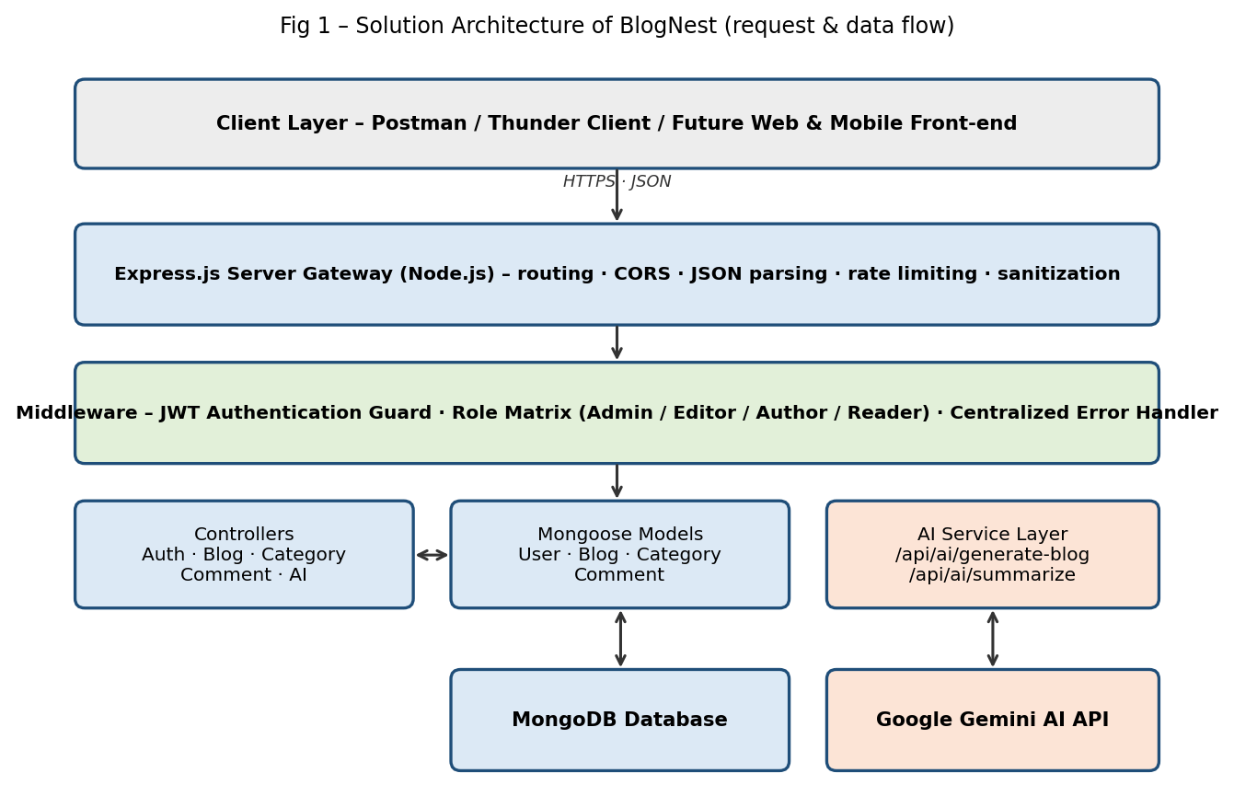
Figure 1: Architecture and data flow of the BlogNest API
Architecture Description:
- Client layer: Postman / Thunder Client (and future web or mobile front-ends) send HTTPS requests with JSON payloads.
- Express server gateway: routes HTTP methods, parses JSON, handles CORS, sanitization and rate limiting.
- Middleware: JWT guard verifies the token, the Role Matrix checks Admin / Editor / Author / Reader permissions, and the centralized error handler returns consistent JSON errors.
- Controllers and models (MVC): Auth, Blog, Category, Comment and AI controllers apply business rules and use Mongoose models to read and write MongoDB.
- AI service layer: /api/ai/generate-blog and /api/ai/summarize call Google Gemini AI and return generated content; failures return a graceful fallback response.
- Data store: MongoDB holds the User, Blog, Category and Comment collections.

Reference: MVC architecture pattern and REST design used in the BlogNest project documentation (Phase 3 – Project Design).

